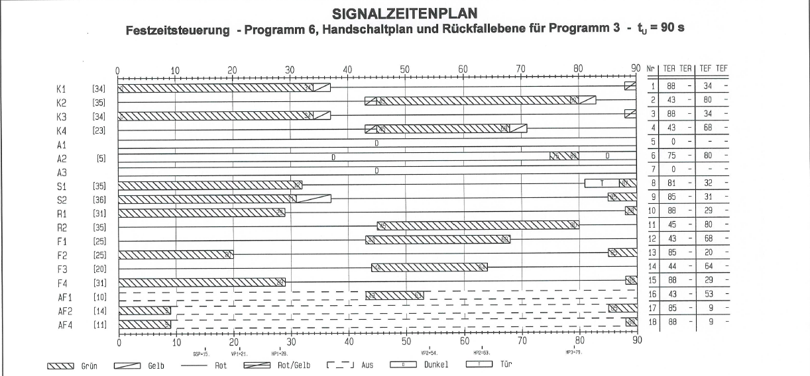

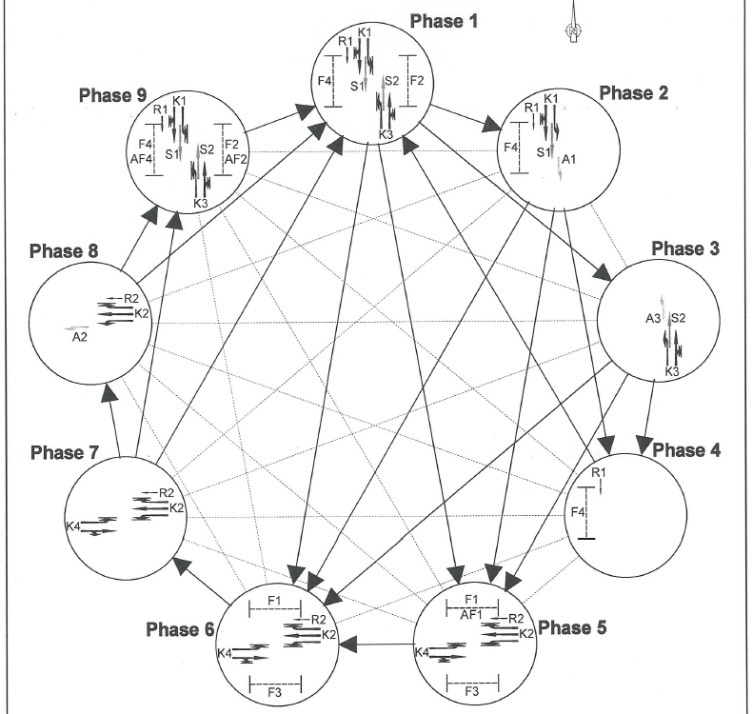

K -- car Signal

S -- Tram signal

R -- Cyclist signal

F -- Pedestrians signal

AF -- Adjacent right turning cars waiting for pedestrians

A -- cars turning left from a junction cutting the opposite straight road.

**Phase 4 (88 - 90 Secs):**

1. Cyclists passing from LSN to LSS across Am Fuchsberg.
2. Pedestrians crossing across AM Fuchsberg.
3. Nothing else is active

**Phase 4 ***(It can change to Phase 9 as well, not shown in Data)**

**Phase 1**

**Phase 1 (0 - 20 secs):**

1. Cars from both sides of LS start moving with green light.
2. Pedestrians and cyclist crossing across AM Fuchsberg
3. Bicyclists (R1) going from LSN to LSS.
4. Trams allowed.
5. Pedestrians crossing across EWS.



**Phase 2 Phase 3 Phase 5 Phase6**

**Phase 2 (21-34 secs):**

1. Cars from LSN can go straight to LSN south
2. Trams allowed
3. Pedestrians and cyclists crossing across AM Fuchsberg.(**Up tp 29th second**)
4. Card turning left from LSN to EWS. Hence all traffic from LSS is blocked as well as no pedestrians can cross ERS

**Phase 3( 21 - 34 secs):**

1. Cars from LSS still can go straight to LSS as the lights are green
2. Trams allowed
3. Cars turning left from LSS to AM Fuchsberg block the traffic from LSN.(This only possible if there is no pedestrian crossing AM Fuchsberg or after 29th second when the pedestrian signal is closed)

**Both Phase 2 and phase 3 can happen simultaneously as well.**

**Phase2 Phase 3**



**Phase 5 Phase 6**

**Phase 5(43 - 64 secs):**

1. Cars at EWS gets green light
2. Cars at AM Fuchsberg gets green light
3. Pedestrian and cyclists crossing LSN
4. Pedestrians crossing LSS
5. Bicyclists (R2) going from EWS to AMF
6. Cars turning right from EWS to LSN waiting for pedestrians and bicyclists to cross.

**Phase 5 can change only to phase 6**

**Phase 6(43 - 68 secs):**

1. Cars at EWS gets green light
2. Cars at AM Fuchsberg gets green light
3. Pedestrian and cyclists crossing LSN
4. Pedestrians crossing LSS (**Only upto 64th second**)
5. Bicyclists (R2) going from EWS to AMF

**Phase 6 can only change to phase 7**

**Phase 7(64 - 68 secs):**

1. All traffic signals remain green across AM Fuchsberg and EWS.
2. No pedestrians crossing.

**Phase 7**



**Phase 8 Phase 9 Phase 1 ***(Also it can go to Phase 4(Not shown in data)**

**Phase 8 (69 - 80 Secs):**

1. Am Fuchsberg traffic signal turns red.
2. Only EWS is having green light.
3. Cars turning left to LSS.
4. No pedestrians allowed,

**Phase 9 (0 - 20 secs):**

1. Cars from both sides of LS start moving with green light.
2. Trams allowed
3. Pedestrians and cyclists crossing across AM Fuchsberg
4. Pedestrians crossing across EWS.
5. Cars turning right waiting for pedestrians to cross on both AM Fuchsberg and EWS.

**Phase9 changes to phase1.**